**Installing Arduino**

① Arduino is an open source software designed to facilitate code writing for Arduino boards. Go to [**http://arduino.cc/**](http://arduino.cc/) to download the software for free. Click **SOFTWARE** -> **DOWNLADS**.



② Click ‘**Windows** **Installer**’.

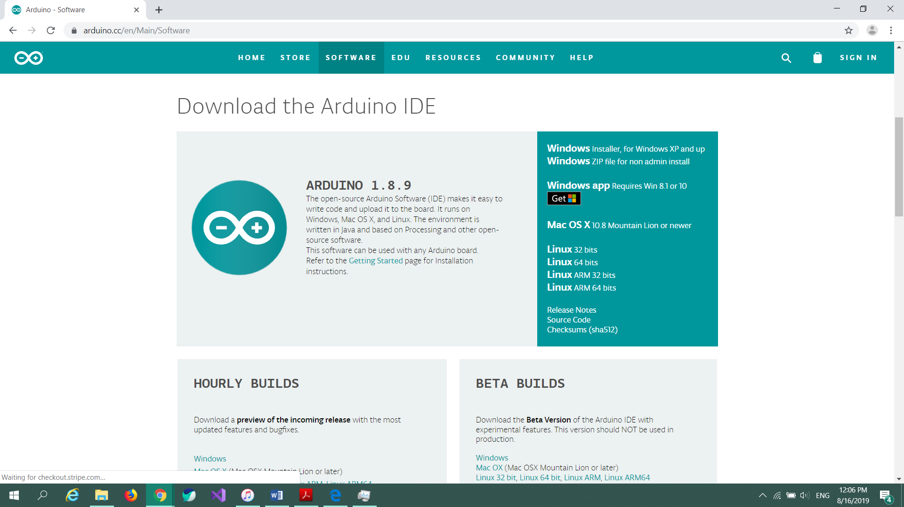

③ Click ‘**JUST DOWNLOAD**’.



④ Run the installed file.



⑤ Click ‘**Install anyway**’.



⑥ Agree to License Agreement by clicking ‘**I Agree**’. Leave all installation options as default and click ‘**Next**’.

 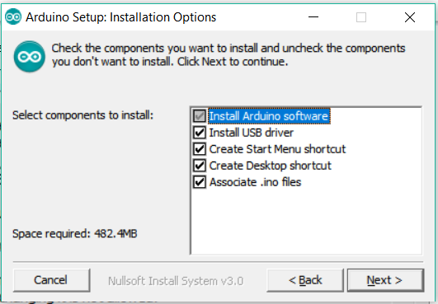

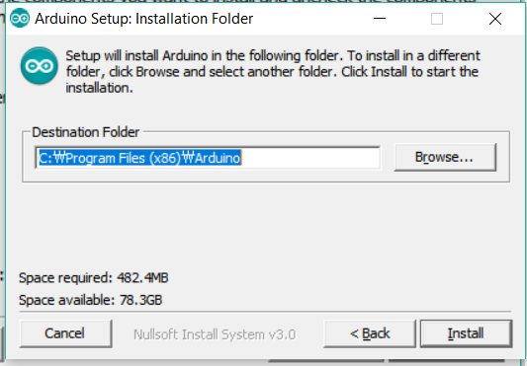 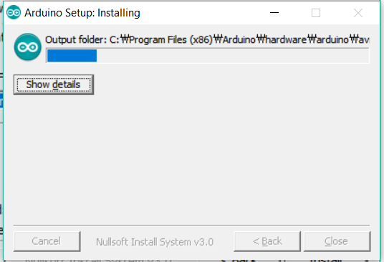

⑦Install all USB driver device software.



⑧Wait for the program to finish installing, then click ‘**Close**’.

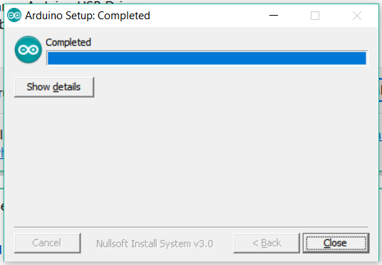

⑨ Find the Arduino shortcut on your Desktop and click it to launch the program. If Windows Security Alert pops up, click ‘**Allow access**’.

 

⑩ The IDE will open and you will see the code editor.

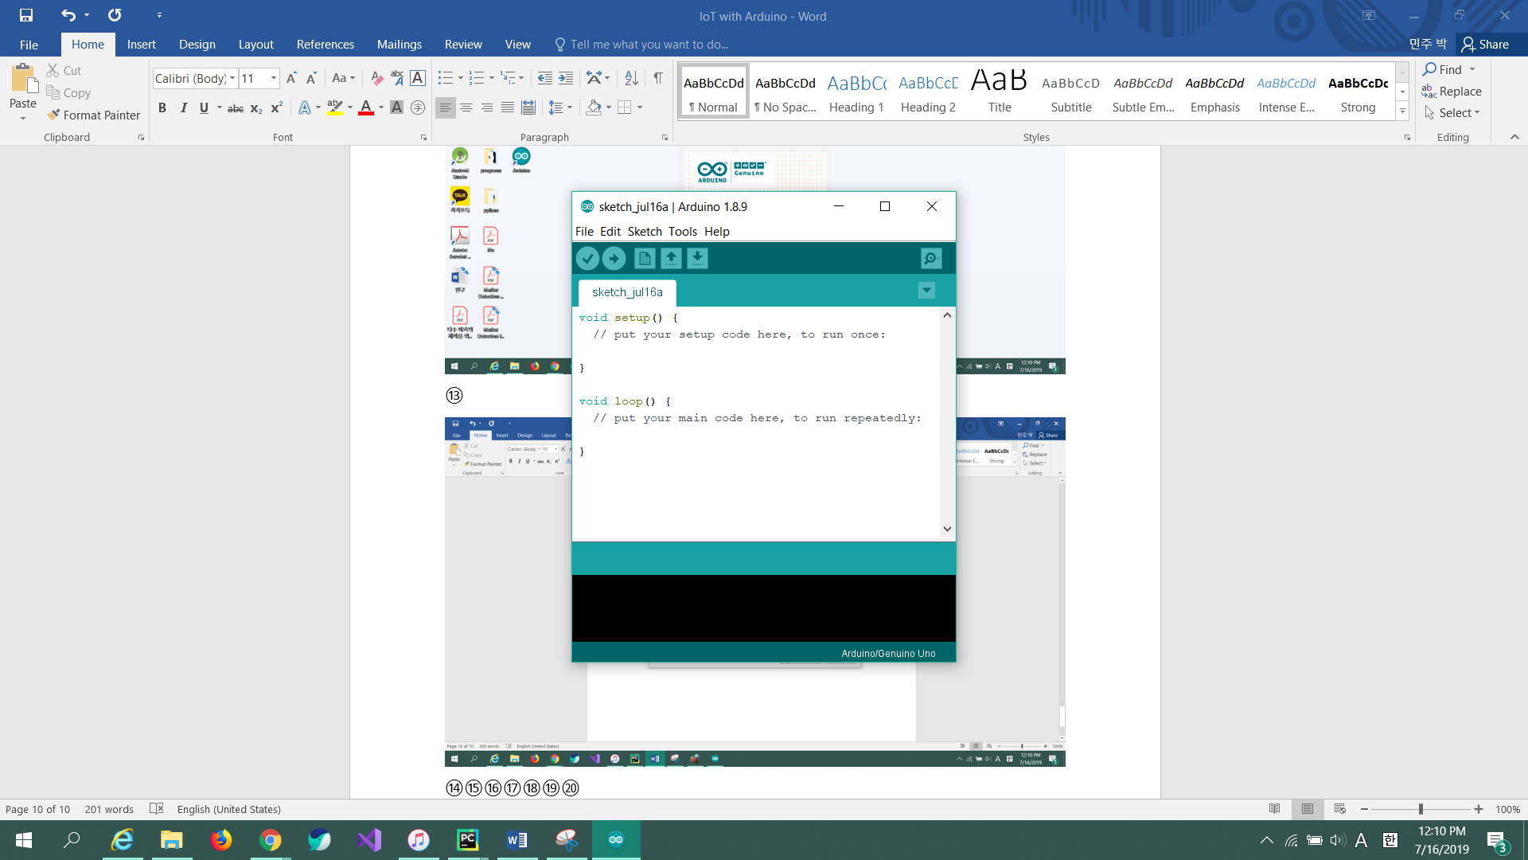

**Setting**

① Go to shared folder by typing in the following address to download source codes and libraries.

Shared folder: **\\192.168.0.180**

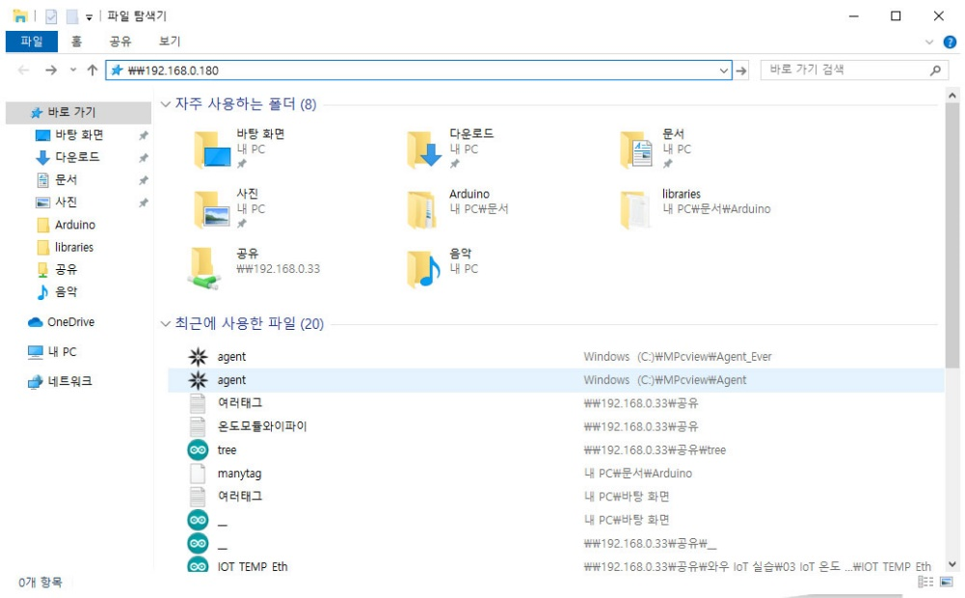

Then, follow the path below.

**Users** – **1** – **Desktop** – **IoT_Starter_Kit**

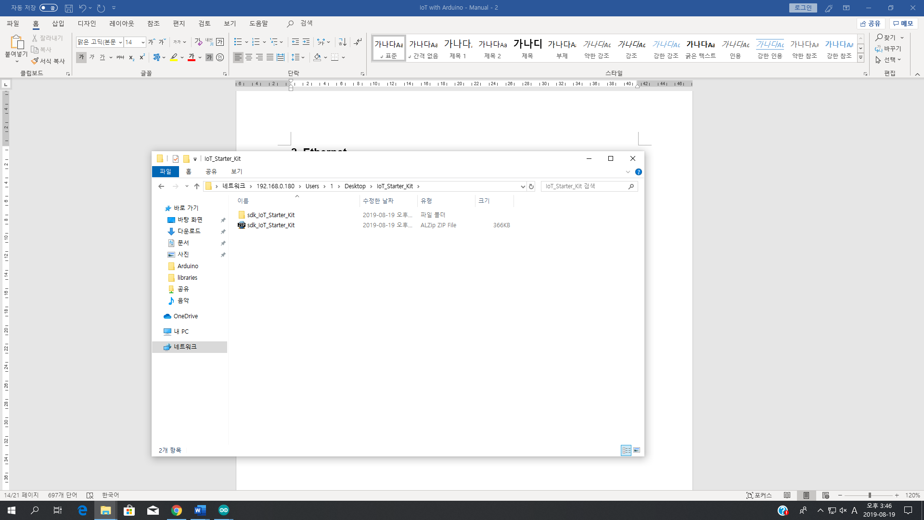

② Copy the folder to desktop.

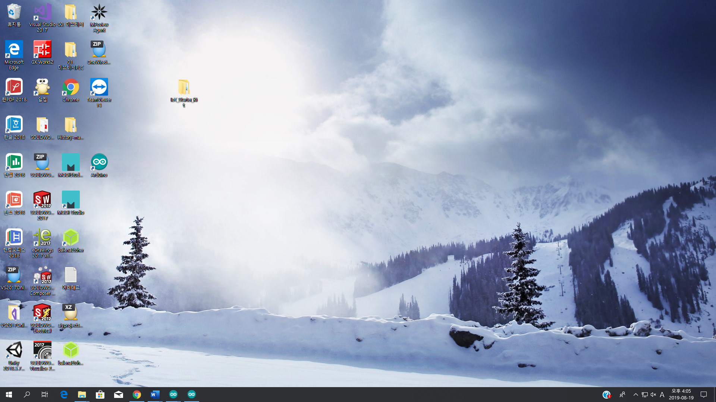

**Checking Connection – LED**

**1. USB Cable**

① Connect the **LED Module** to the **target board**. There is a connecter on the bottom of the target board. When connecting the module, the arrow on the module must be facing the arrow on the target board. If the module is connected upside down, the connecting pins may be connected in the opposite direction and can cause malfunctions.

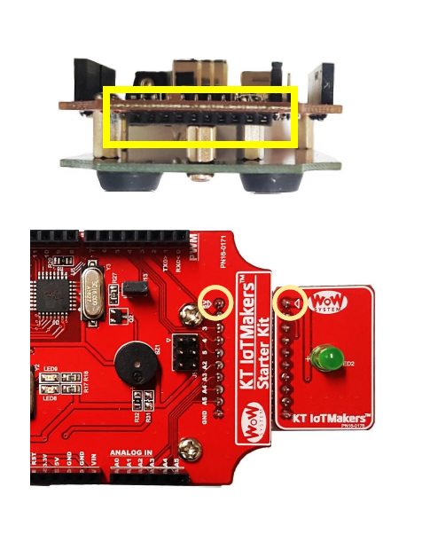

② Connect the **target board** to **host PC** using **USB Cable**.

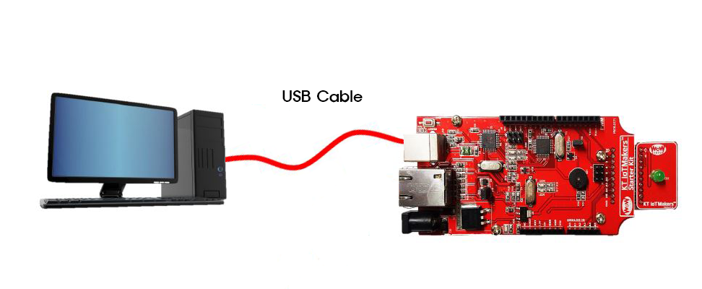

③ Go to ‘**Tools** -> **Board**’ then select ‘**Arduino/Genuino Uno**’.

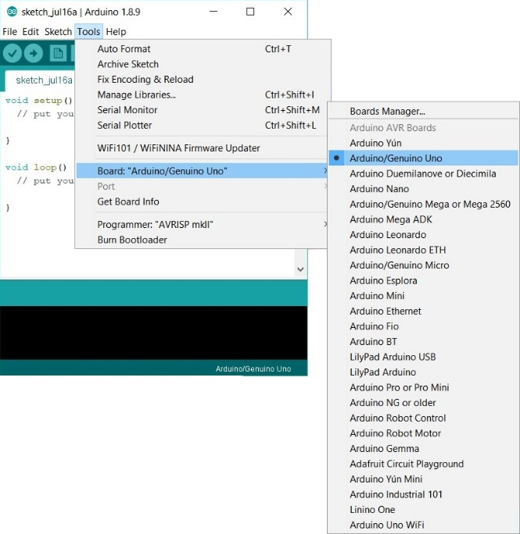

② To set the COM port for the program to download, go to ‘**Tools** –> **Port**’ the select the appropriate port. If the COM port is not listed, double check the Arduino Uno connection. Port number may be different.

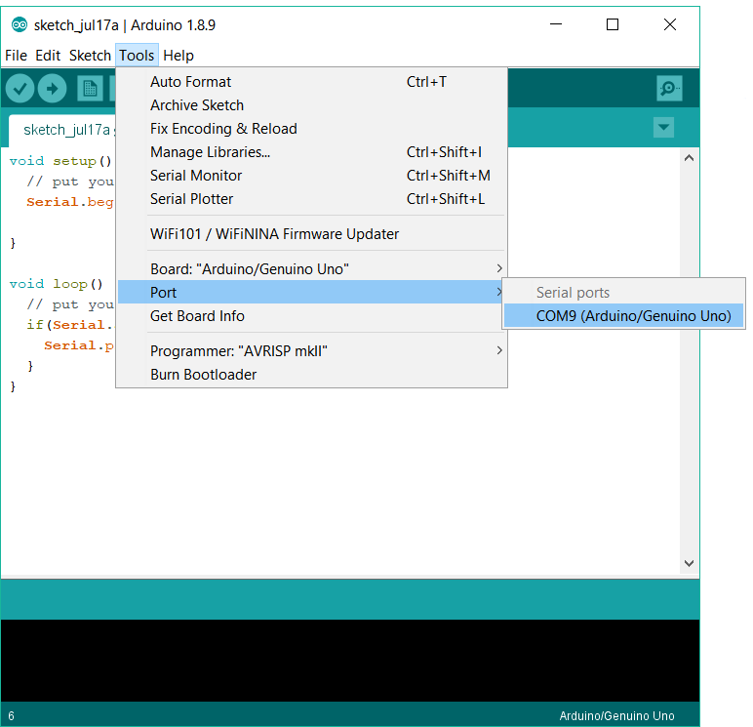

③ Type the following code. The code will turn the LED ON for one second, the OFF for one second, repeatedly.

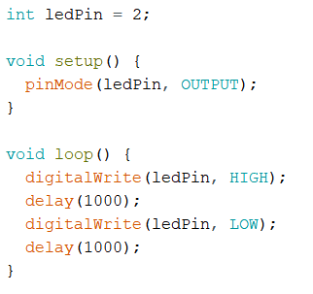

④ Click (upload) button. The LED of the module will turn ON and OFF every 1 second.

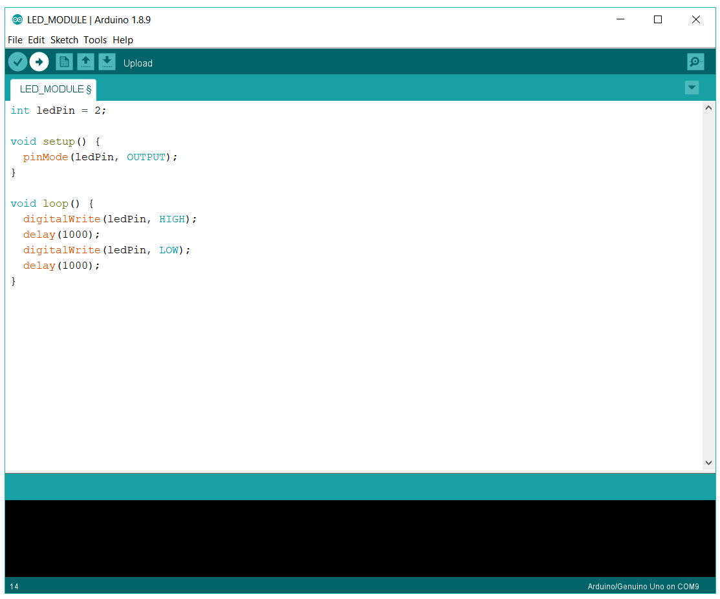 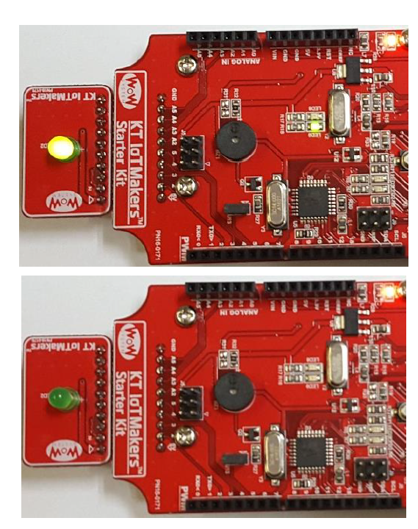

**KT IoTMakers**

① Go to [**http://iotmakers.kt.com**](http://iotmakers.kt.com).



② Change the language to English.



③ Click ‘**SIGN UP**’ to create an account.



④ Agree to Terms of Service by checking the checkbox.



⑤ Fill out your information in the sign up screen. Then click ‘**Sign Up**’ to finish.

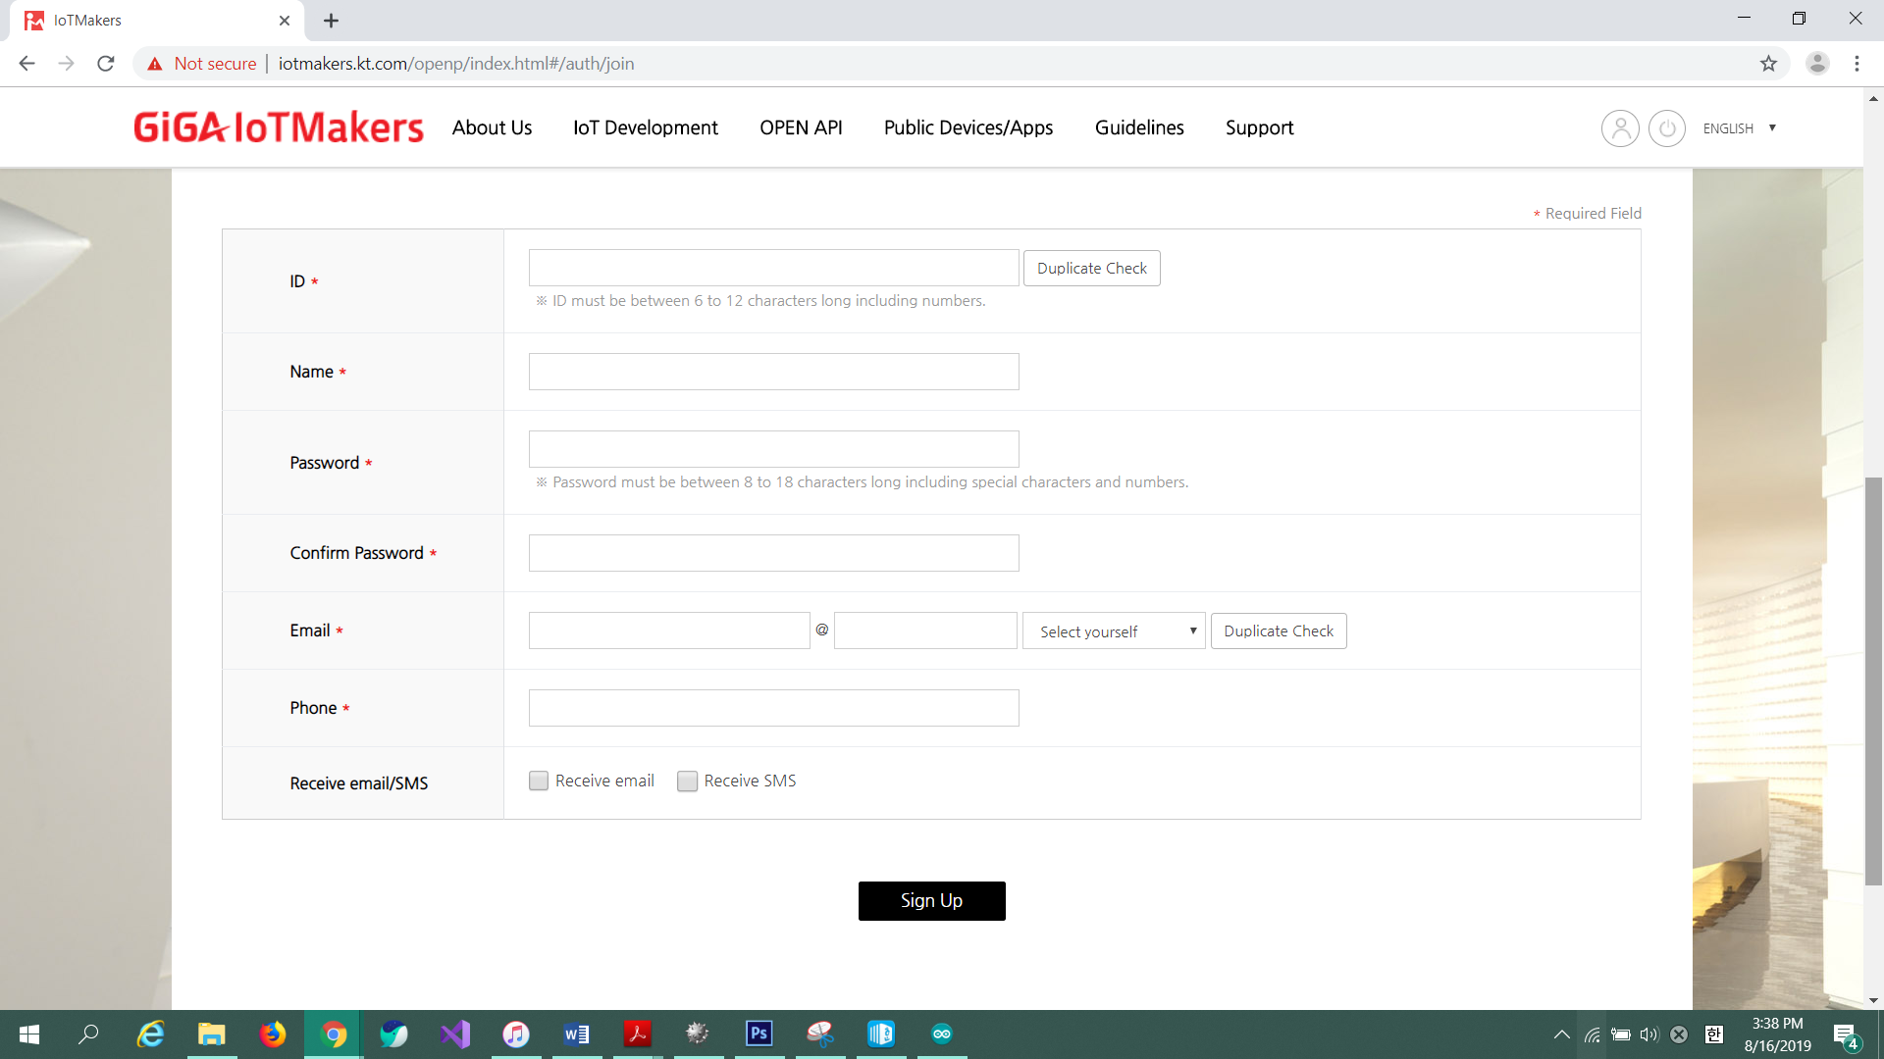

⑥ Login to IoTMakers.

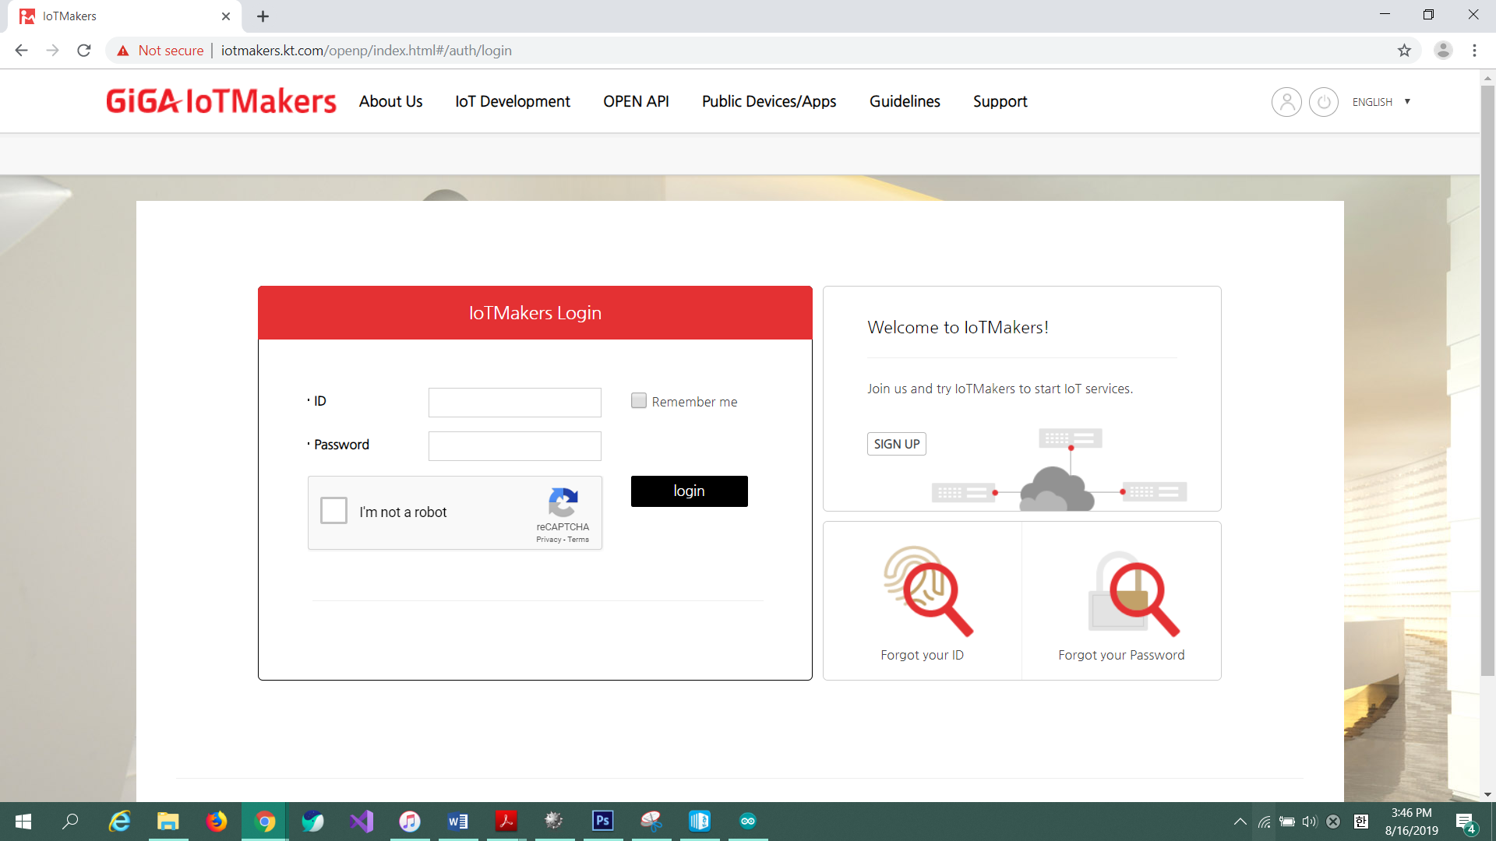

⑦ If your name shows up, login is complete.



**2. Ethernet**

① Connect the **LED Module** to the **target board**.



② Go to ‘**IoT_Starter_Kit** – **Examples** – **02 Ethernet** – **IOT_LED_Eth**’ and open ‘**IOT_LED_Eth**’.

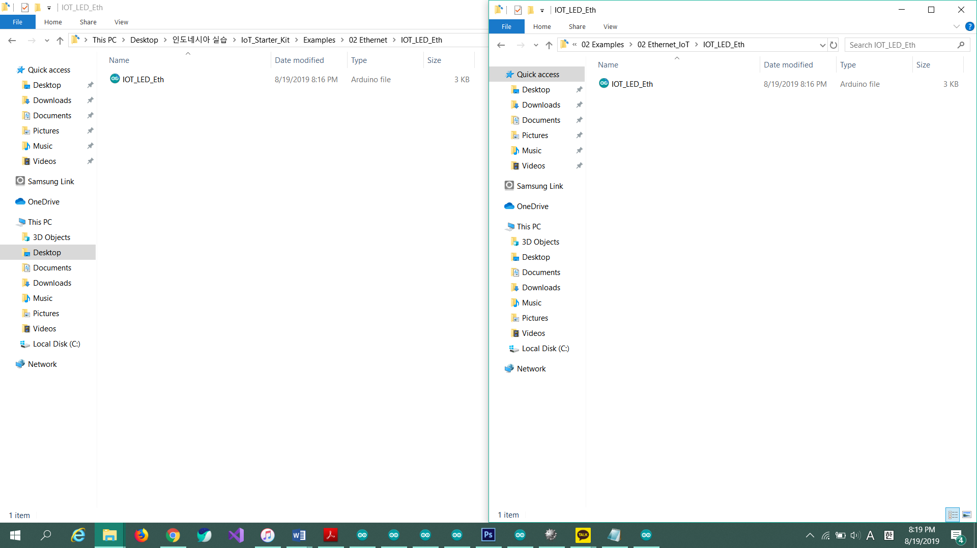

③ Include ‘**IoTStarterKit_Eth.h**’ library. Click ‘**Sketch** – **Include Library** – **Add .ZIP Library…**’

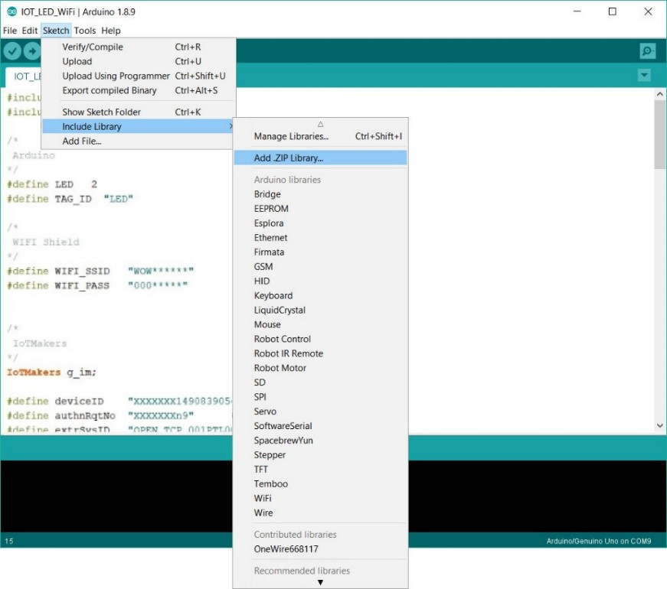

④ Go to ‘**IoT_Starter_Kit** - **Library**’ then select ‘**IoTStarterKit_WiFi.zip**’ then click ‘**Open**’. The file must be a zip file.

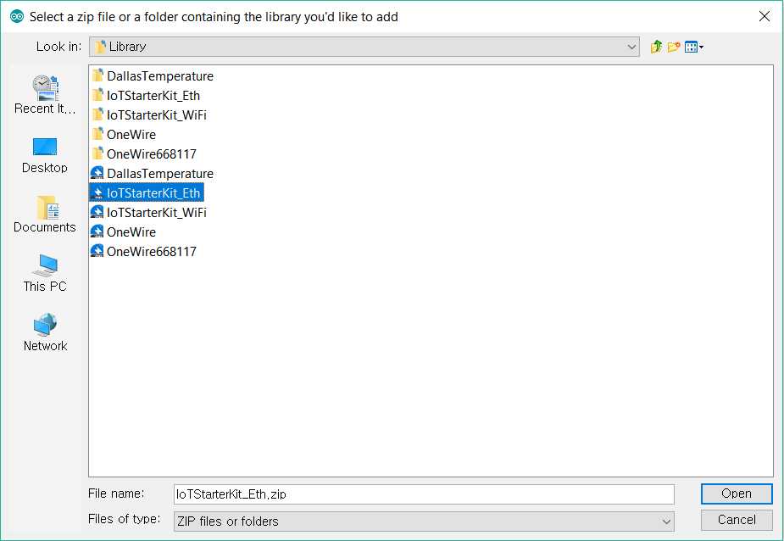

⑤ Open **IoTMakers** then go to ‘**IoT Development** – **Devices**’.



⑥ To register the device, click ‘**Register Device**’.

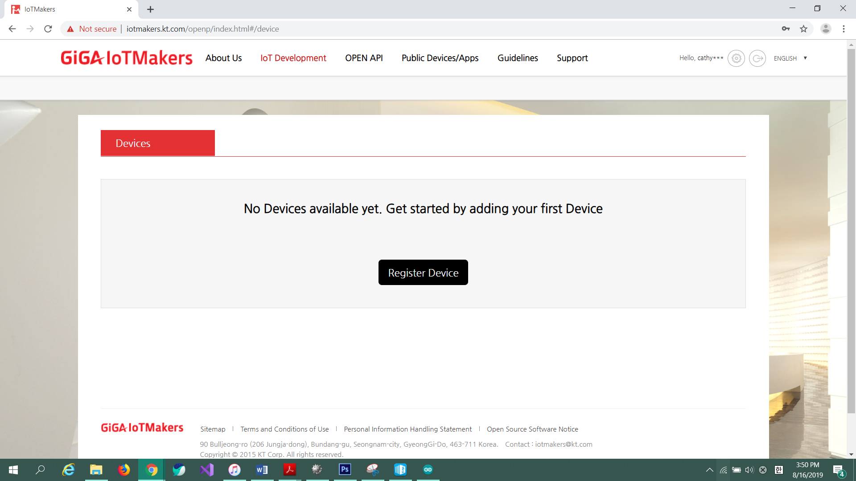

⑦ Enter the device name as ‘**KIT LED E**’ and use the default values for the device ID and password. Then click ‘**Register Device**’.

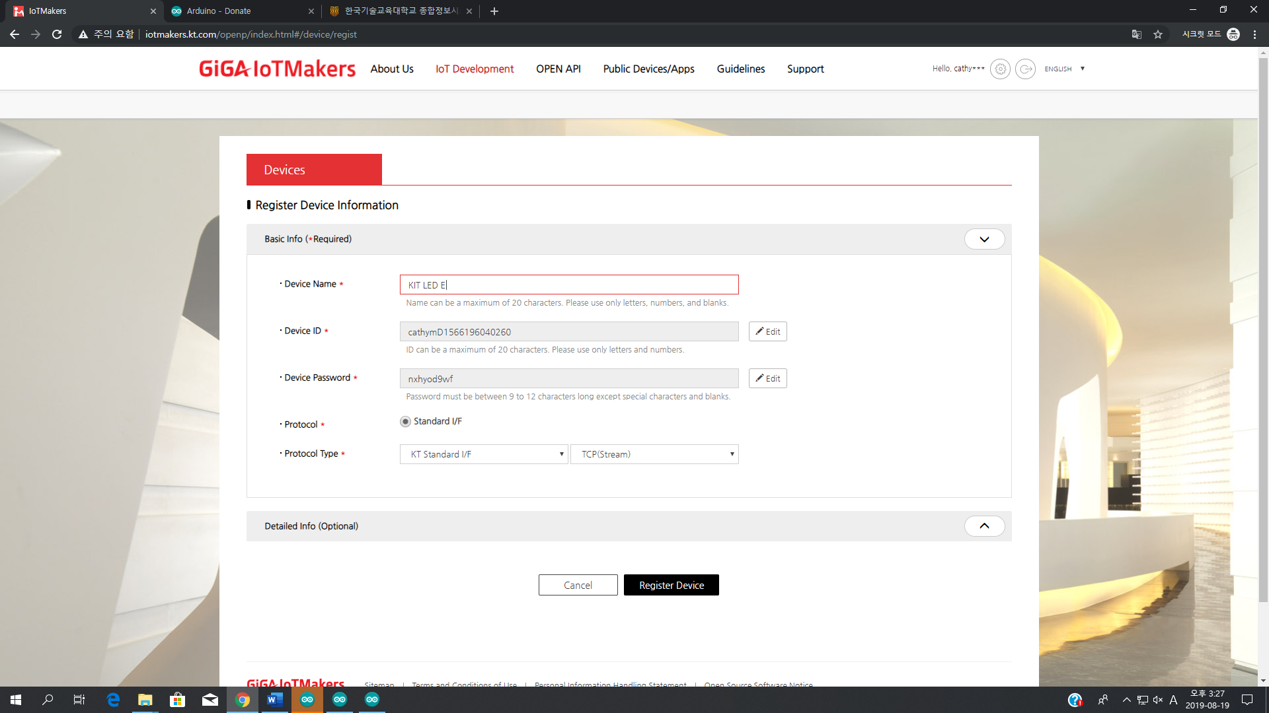

⑧ Click the list to see the detailed information about the device.

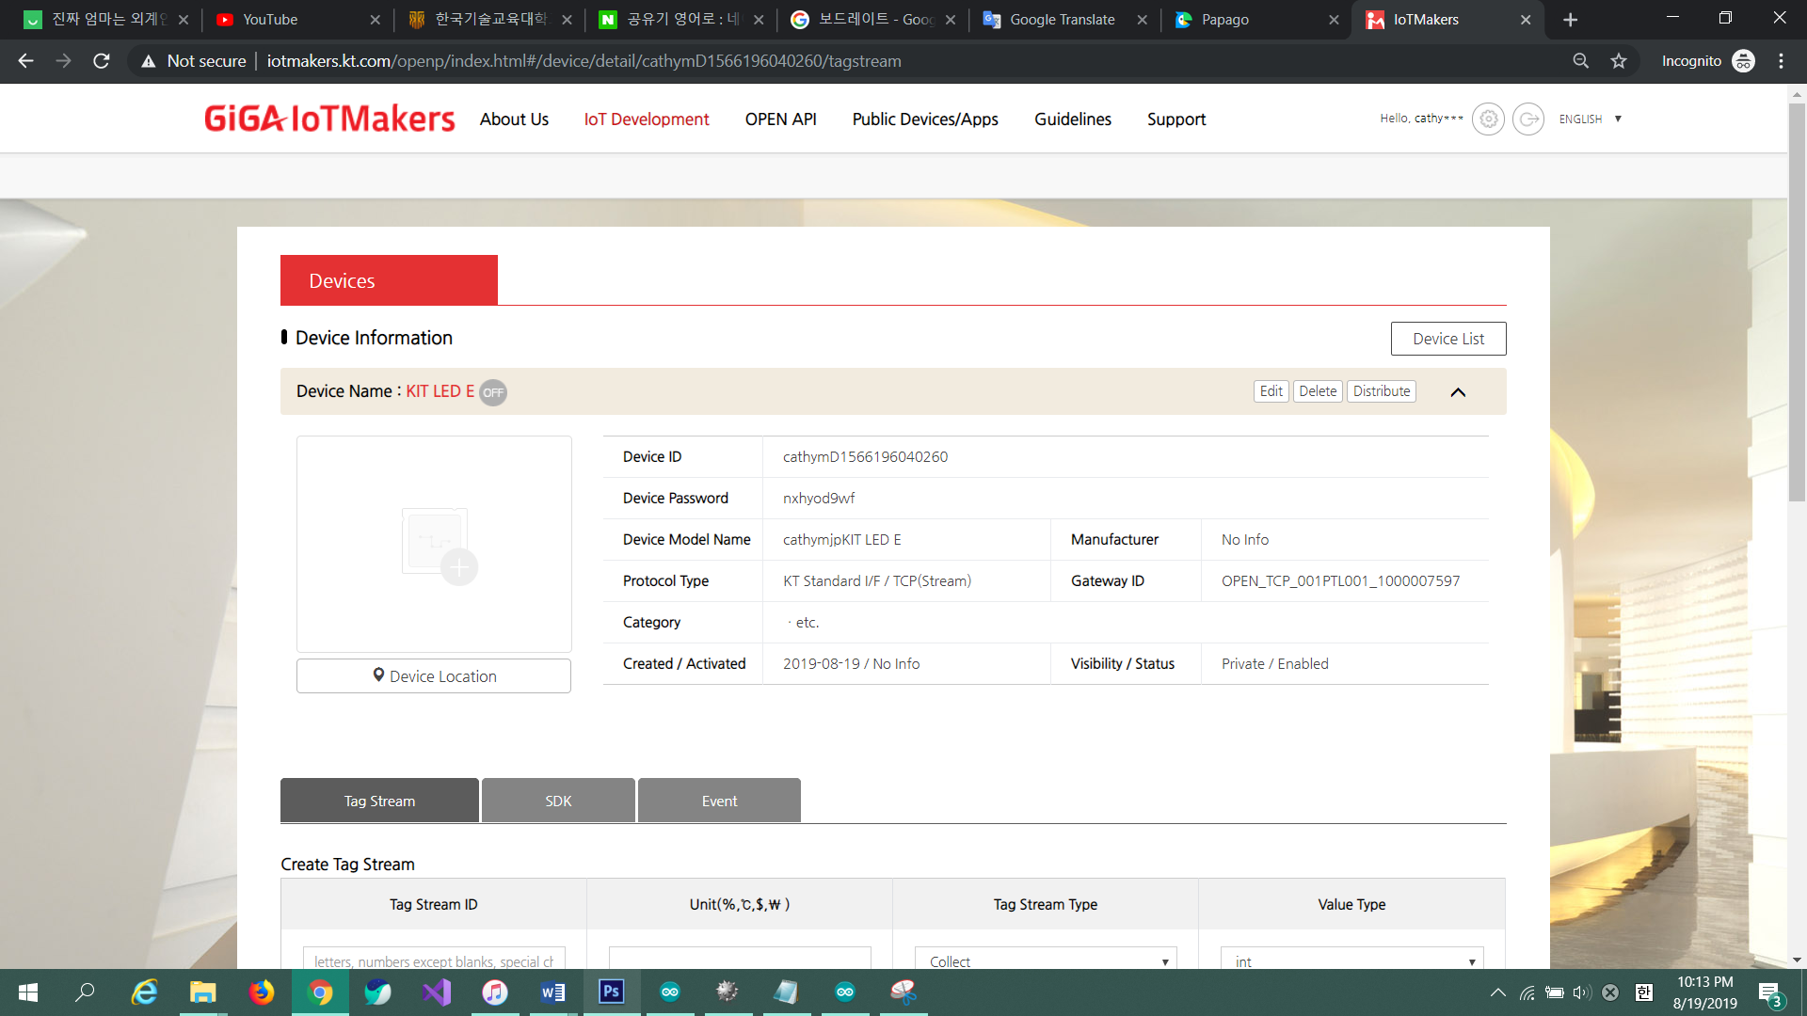

⑨ Copy **Device ID**, **Device Password**, **Gateway ID**. Then change **MAC address** located at the **bottom of the target board**.

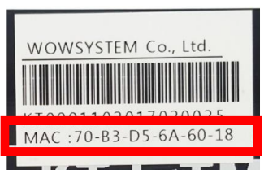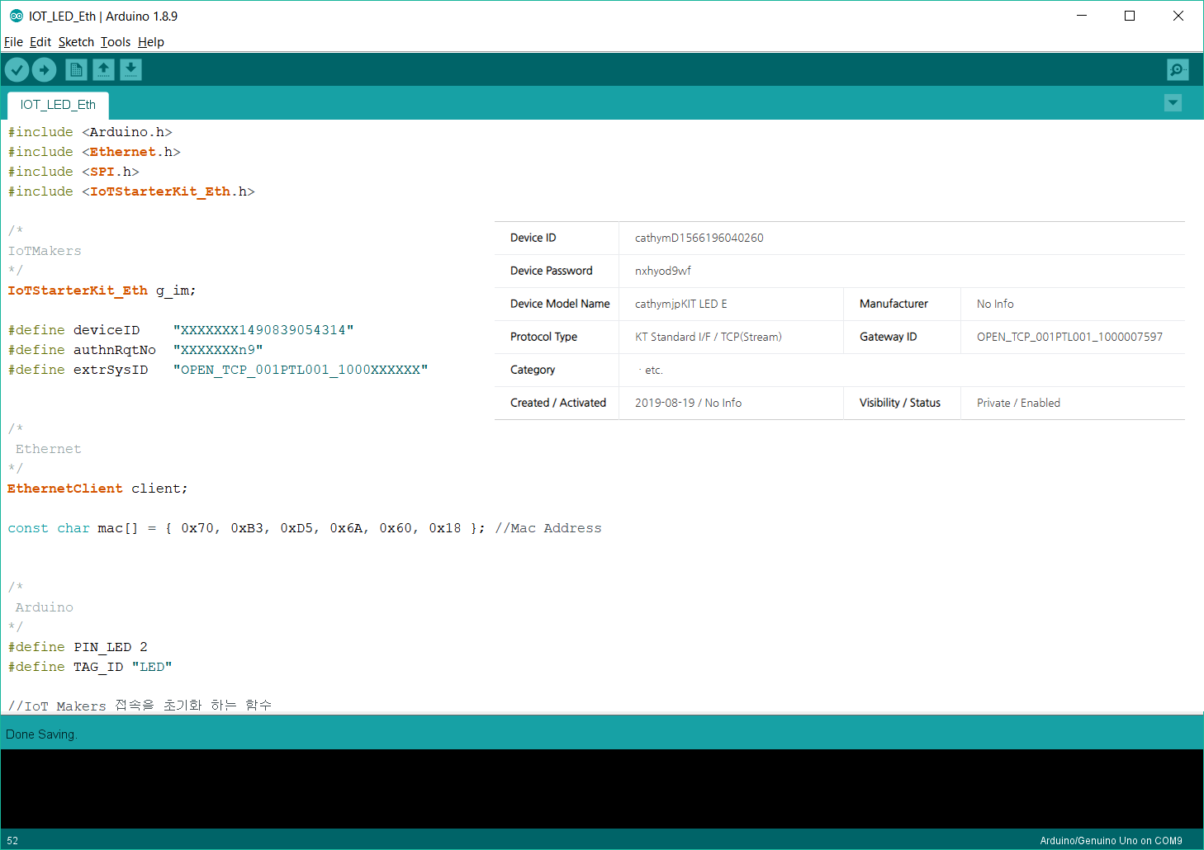

⑩ Connect the **target board** with **host PC** using **USB Cable** and with **router** using **Ethernet Cable**. Router is located in the center of the table.

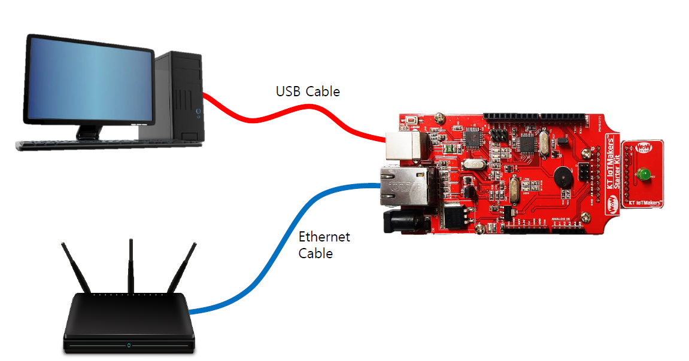

⑪ On IoTMakers, click ‘**Create Tag Stream**’ for the registered device.

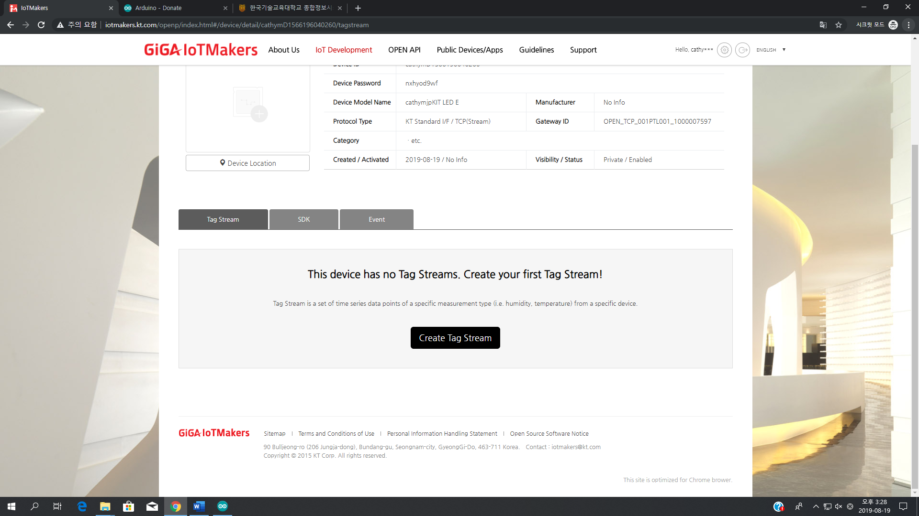

⑫ Enter the following tag stream values then click ‘**Create’**.

|  |  |
| --- | --- |
| **Tag Stream ID** | LED |
| **Unit** | - |
| **Tag Stream Type** | Control |
| **Value Type** | String |

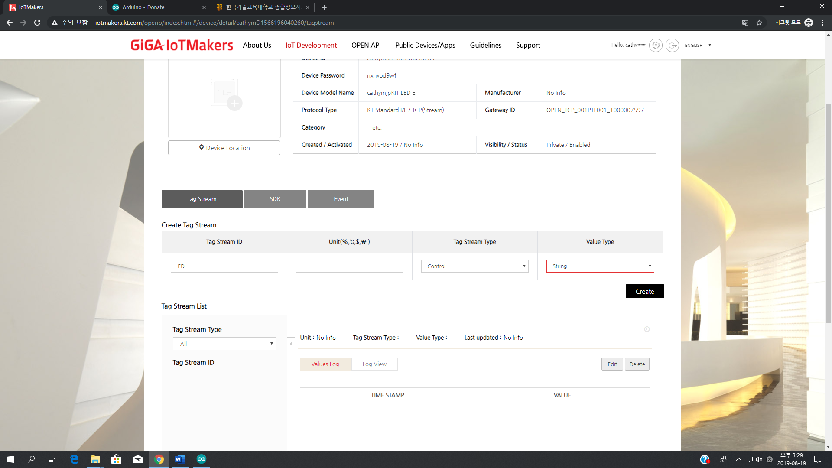

⑬ Upload the file. If the message on the bottom is displayed as blue, uploading is successful.

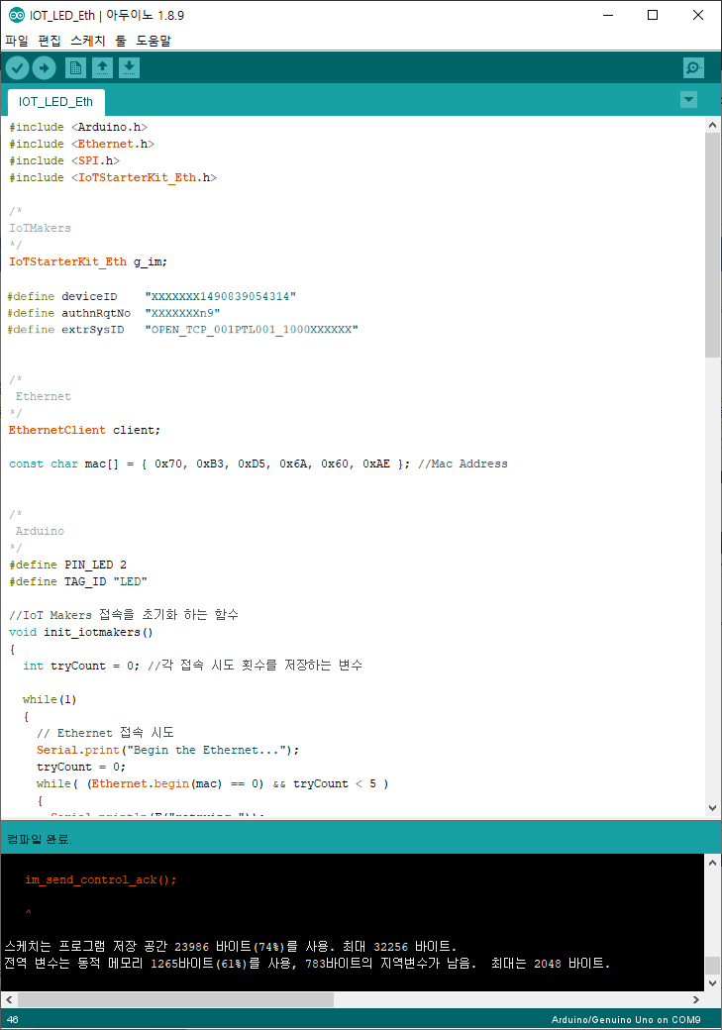

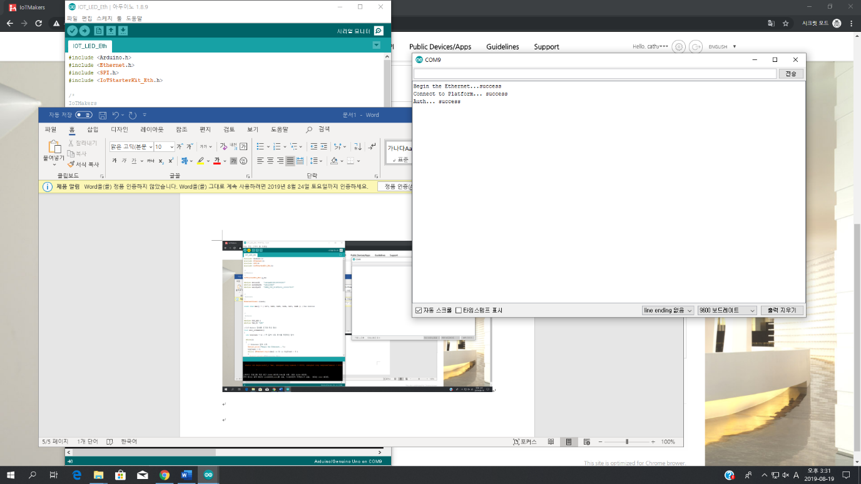⑭ Click ‘**Serial Monitor**’. Make sure Baud Rate is set to 9600. If the message is displayed as below, it has been connected successfully.



⑮ Pass **control values** to control the LED. Control value should match the value specified in the code.

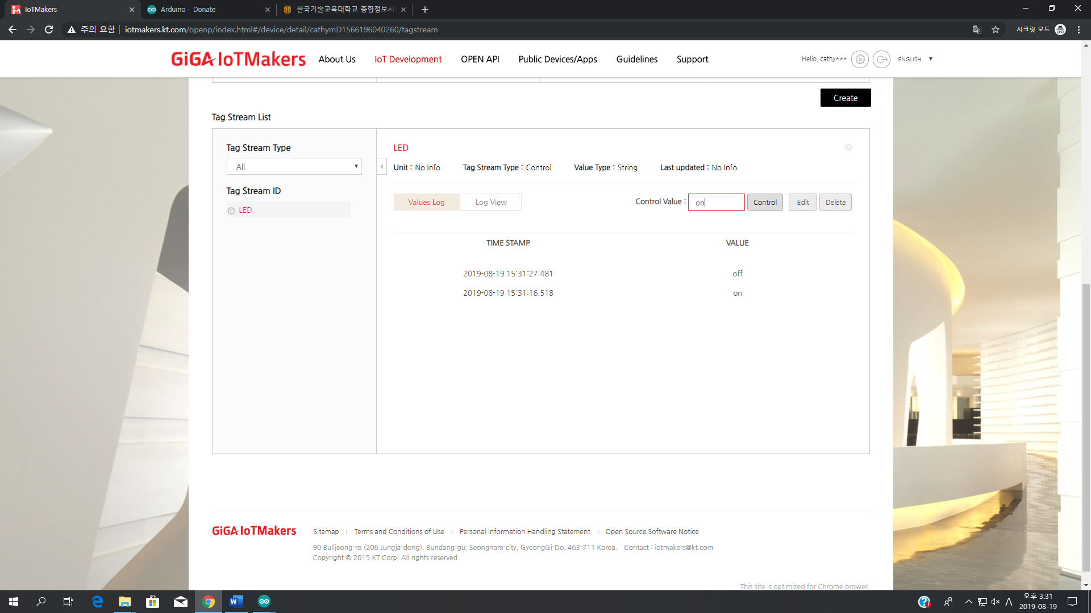

⑯ According to the Control Value, “LED ON” or “LED OFF” is output on the serial monitor, and the LED of the target board is also turned on/off.

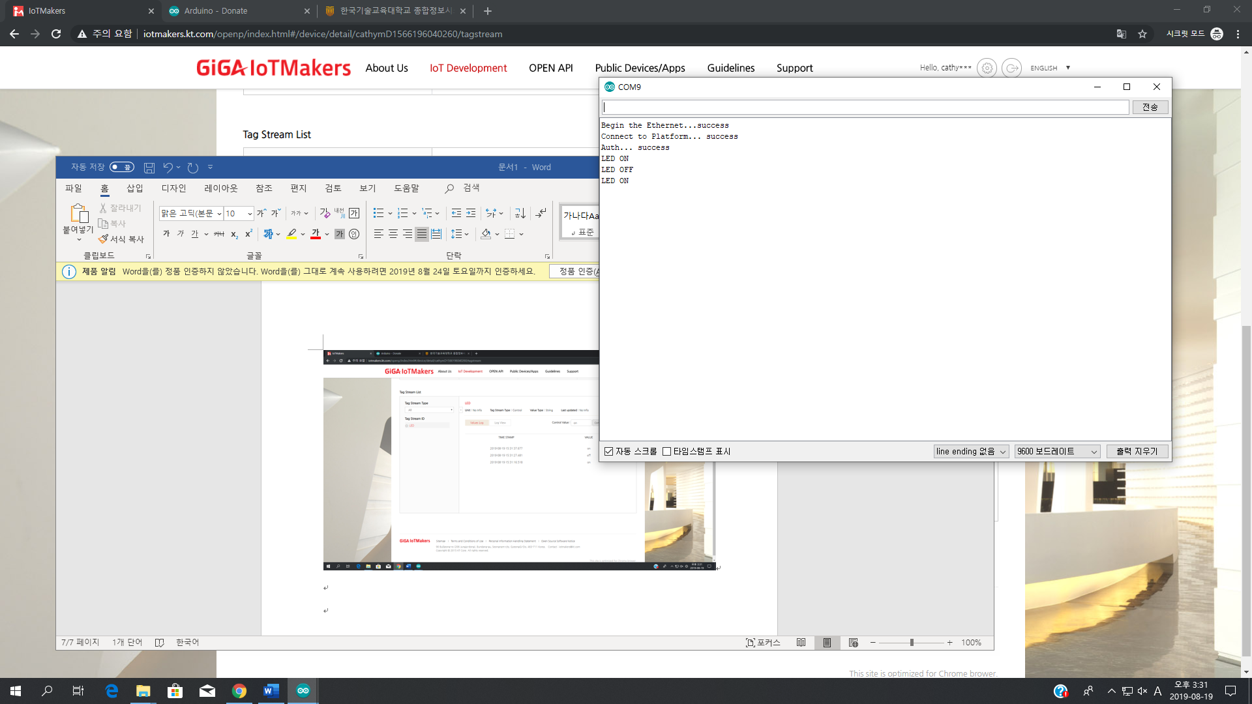 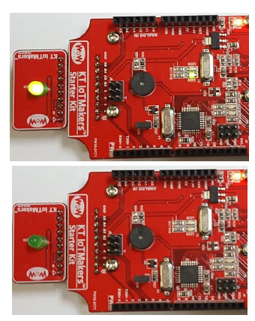

**3. WiFi**

① Connect the **LED Module** to the **target board**.



② Connect the **WiFi Shield** to the **target board**. There are connectors for connection on the left and right sides of the top face of the equipment. Be careful not to bend the pins on the bottom of the shield when connecting the WiFi Shield.

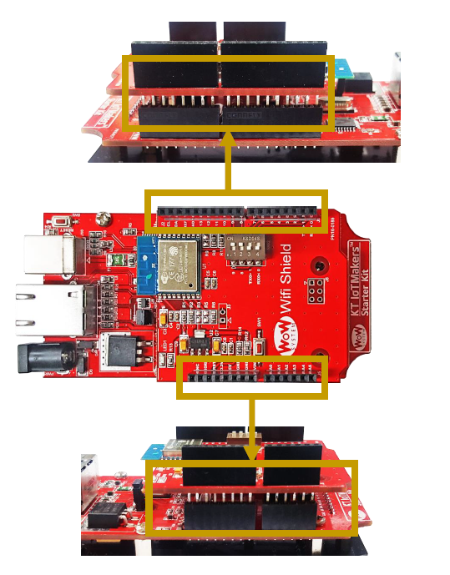

③From ‘**IoT_Starter_Kit**’ folder, click ‘**Examples – 03 WiFi - IOT_LED_WiFi**’ and open ‘**IOT_LED_WiFi**’ Arduino file.

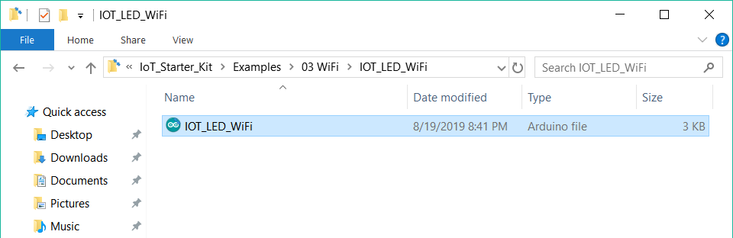

④ Include ‘**IoTStarterKit_WiFi.h**’ library. Click ‘**Sketch** – **Include Library** – **Add .ZIP Library…**’



⑤Go to ‘**IoT_Starter_Kit** - **Library**’ then select ‘**IoTStarterKit_WiFi.zip**’ then click ‘**Open**’

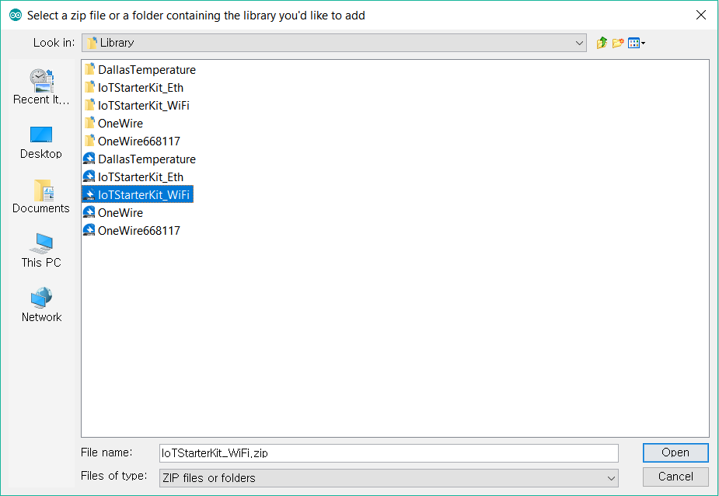

⑥ Connect the **target board** to **host PC** using the **USB Cable**.

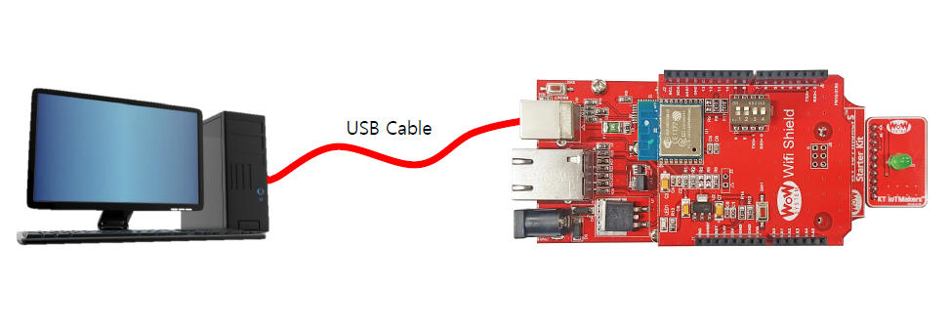

⑦ Open **IoTMakers** then go to ‘**IoT Development** – **Devices**’ and ‘**Register Device**’.





⑧Enter the device name as ‘**KIT LED W**’ then click ‘**Register Device**’.

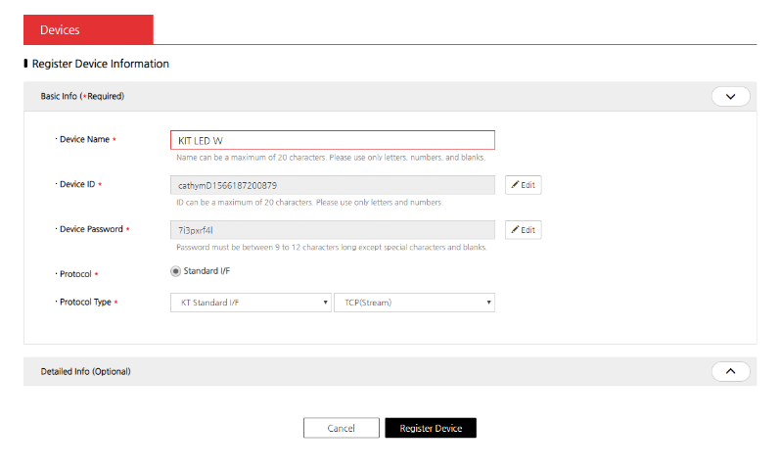

⑨ Enter the device information of ‘KIT LED W’ to connect to KT IoTMakers from KT IoTMakers.

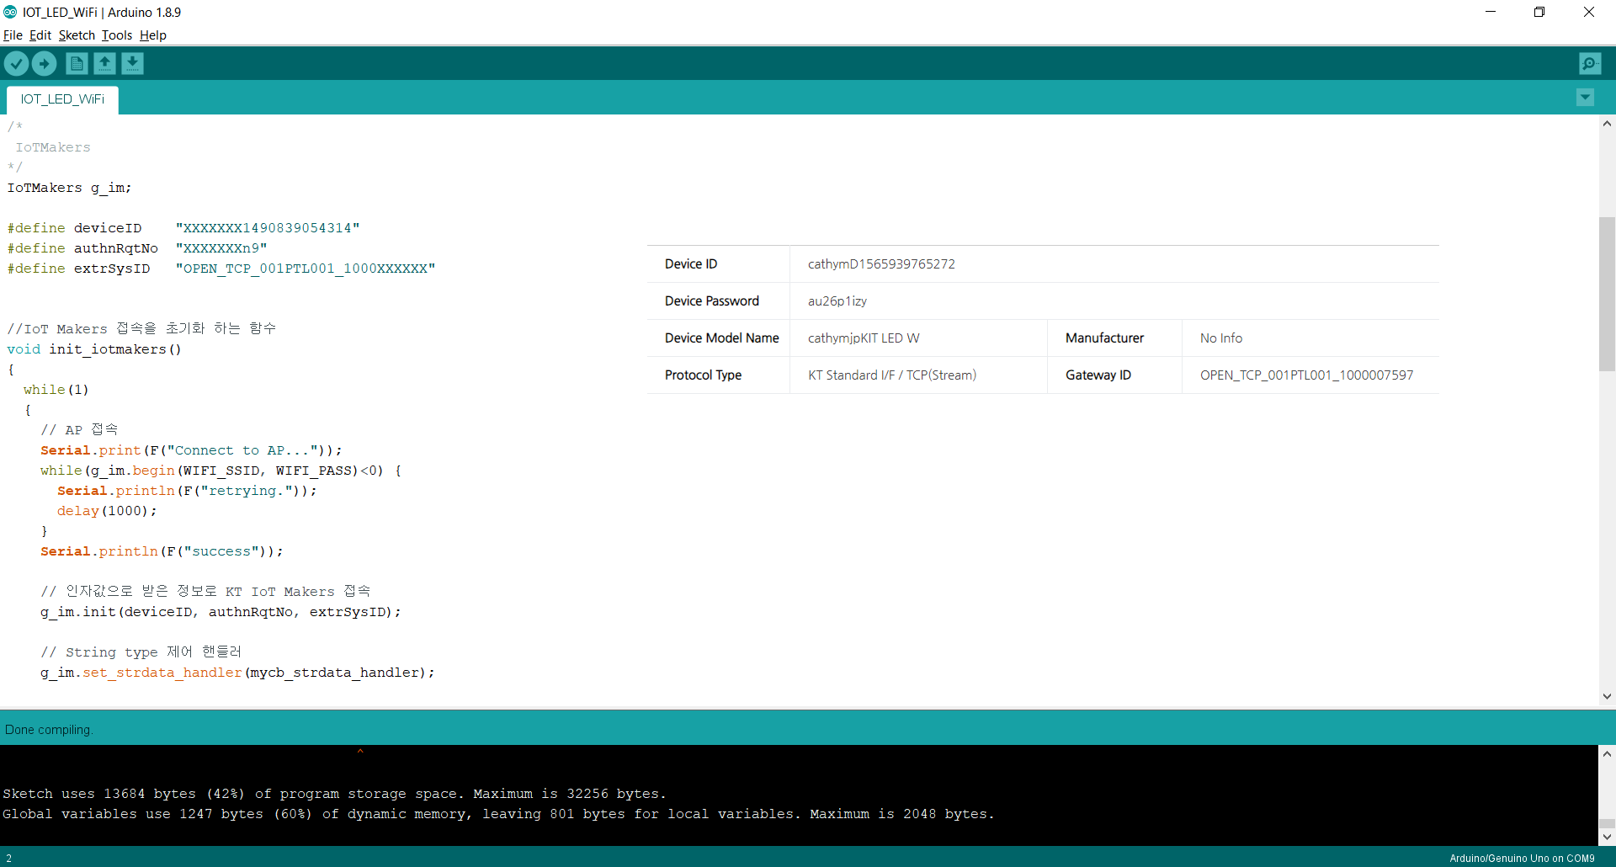

⑩ Change the **WiFi SSID** and **password** to local network.

WiFi SSID: ICT-LAB-2.4G

WiFi Password: 12345678

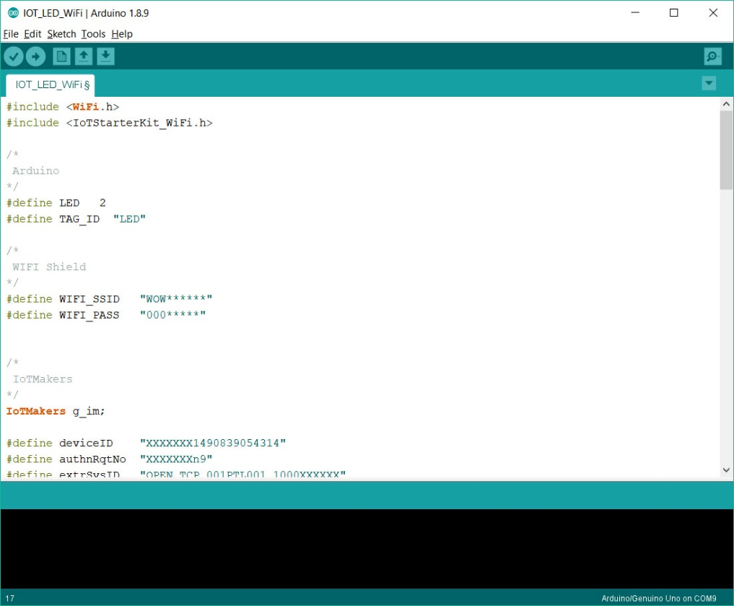

⑪ On IoTMakers, click ‘**Create Tag Stream**’ for the registered device.

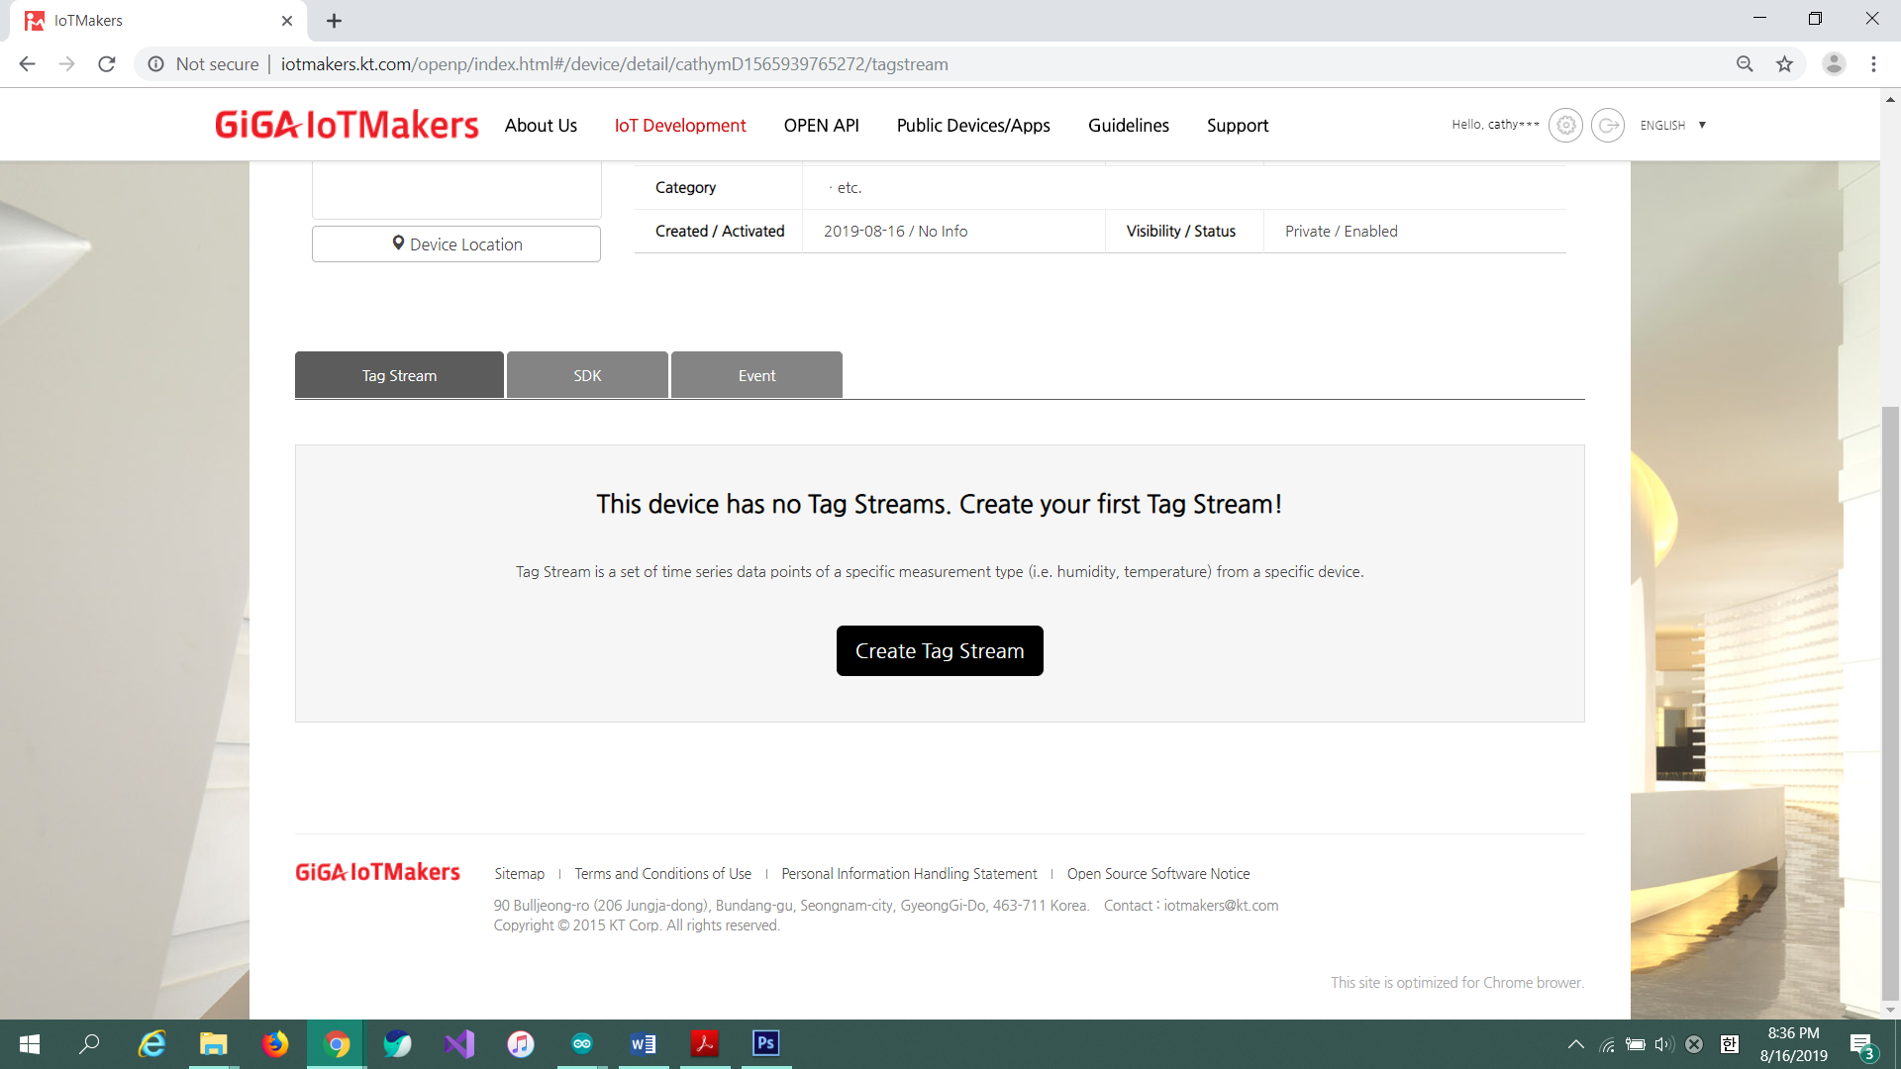

⑫ Enter the following values for tag stream.

|  |  |
| --- | --- |
| **Tag Stream ID** | LED |
| **Unit** | - |
| **Tag Stream Type** | Control |
| **Value Type** | String |

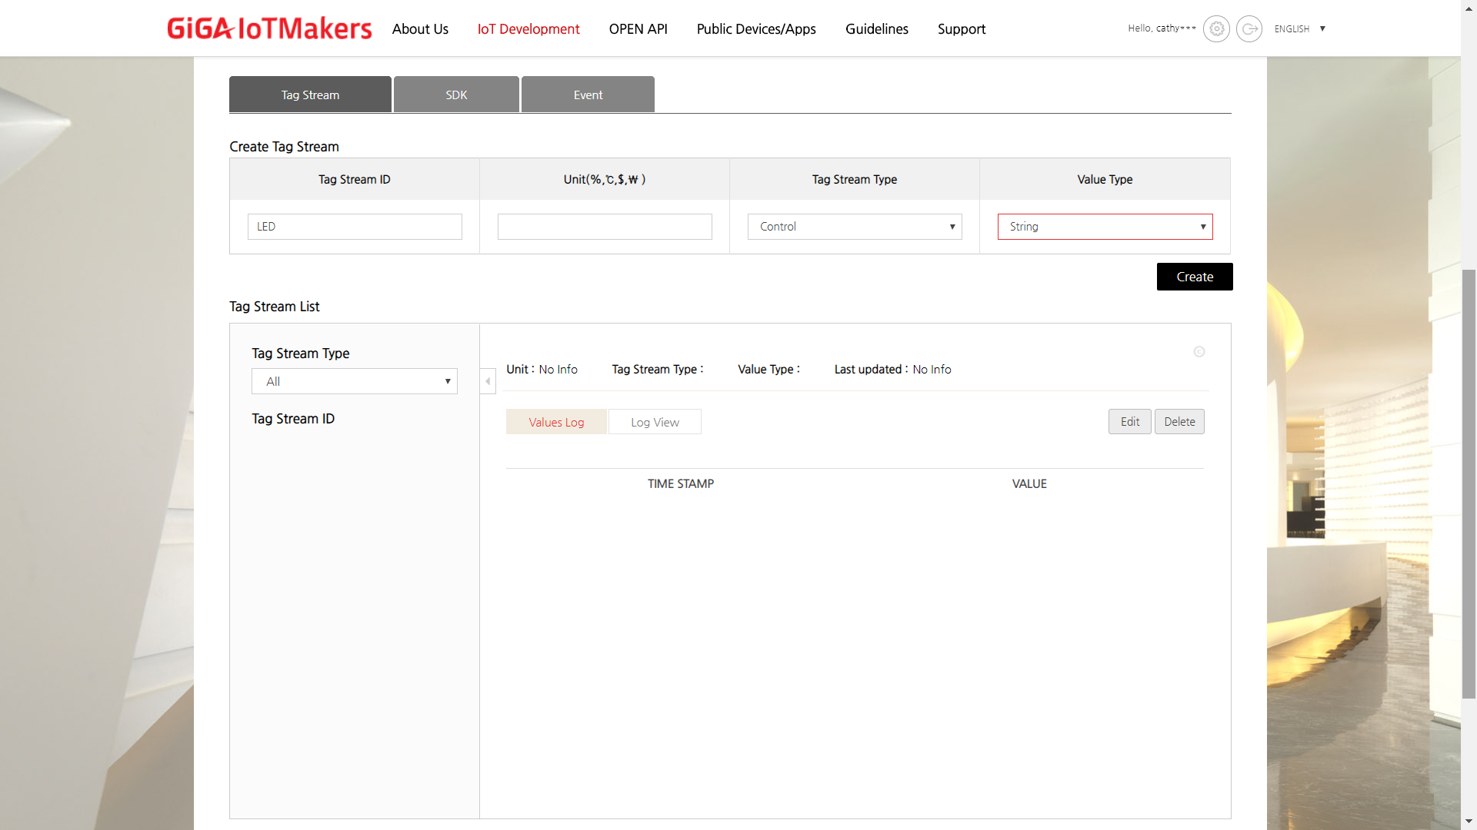

⑬ ⑭Click (**Upload**) button. Wait a few seconds and if the upload is successful, the message ‘**Done uploading**’ will appear in the status bar.

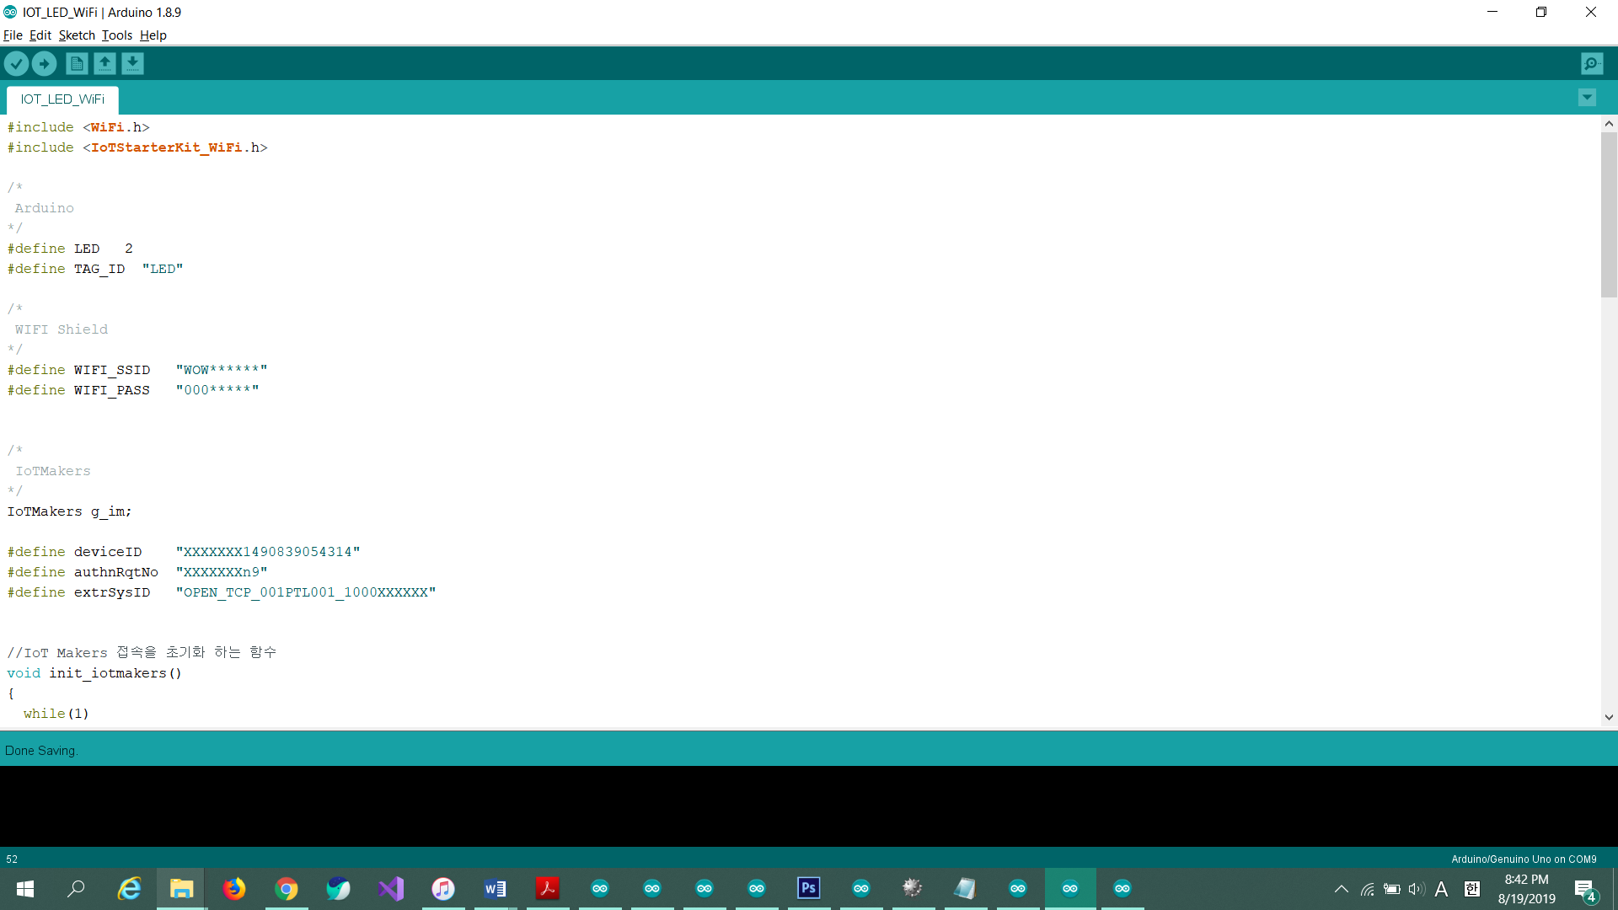

⑮ ⑯ Open Serial Monitor by clicking ‘**Serial Monitor**’ button and set baud rate to **9600 baud**. When the connection to IoTMakers is complete, the following screen is displayed.

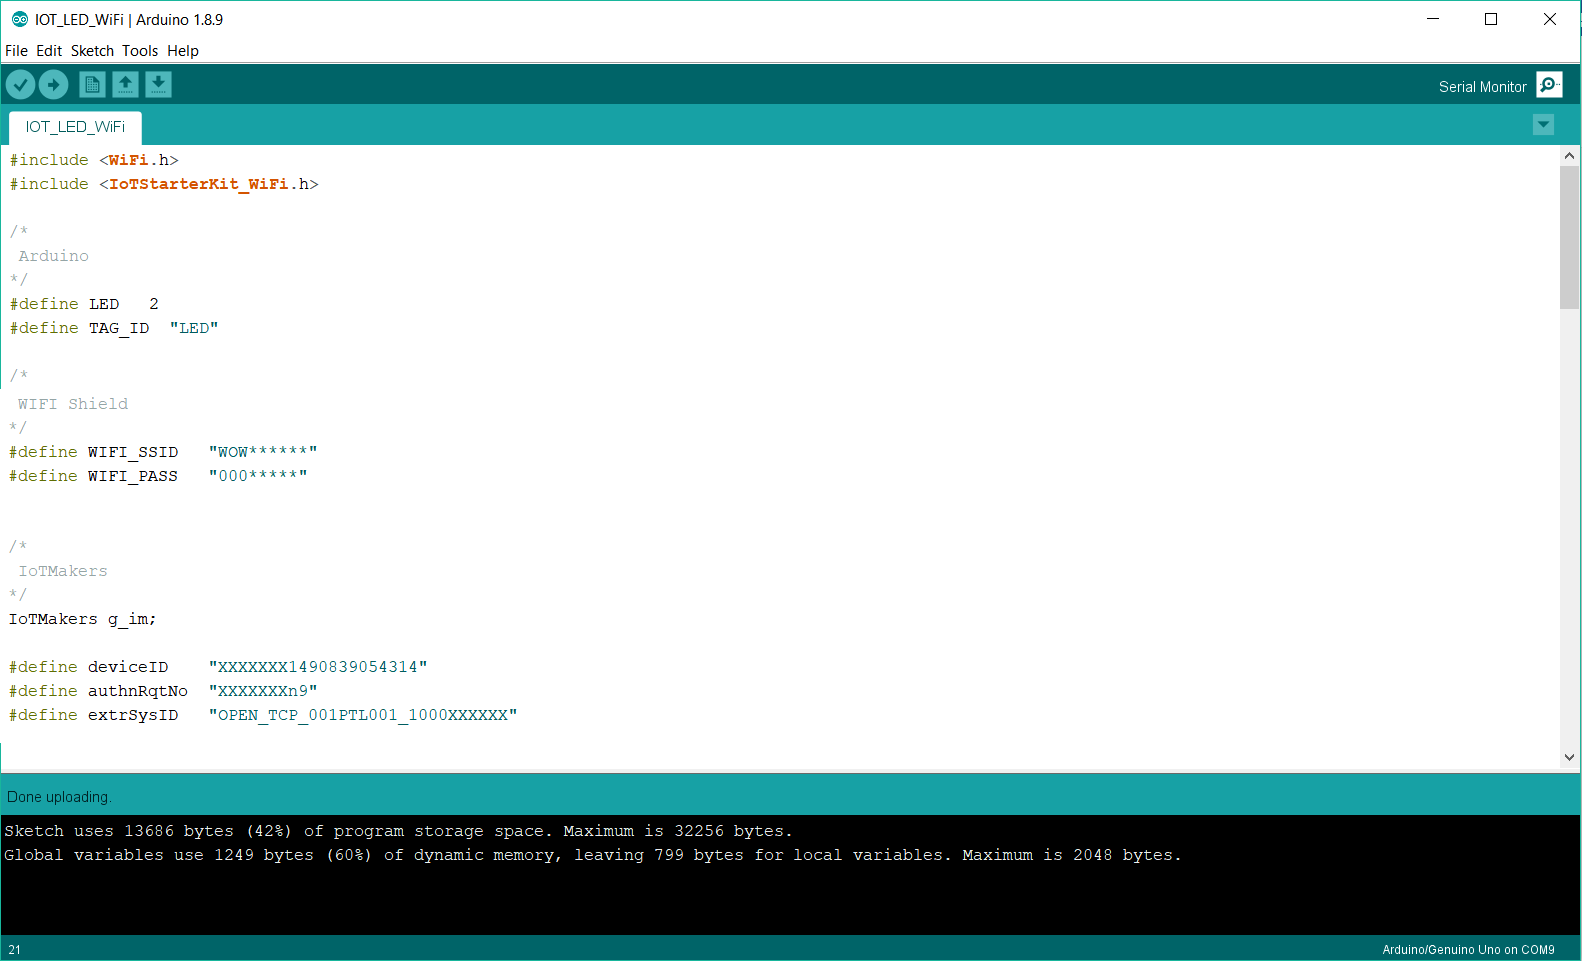 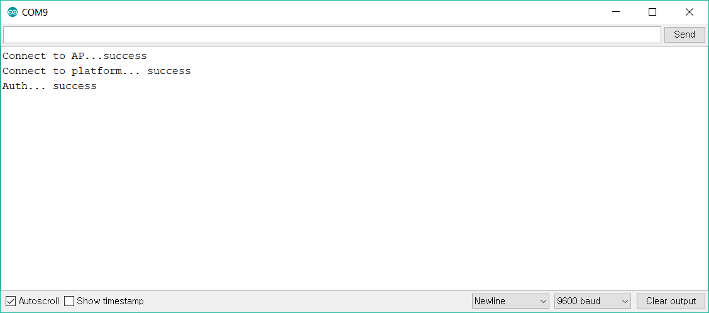

⑰ Send the control value. The input value must be the same as the value defined in ‘IOT_LED_WiFi’.

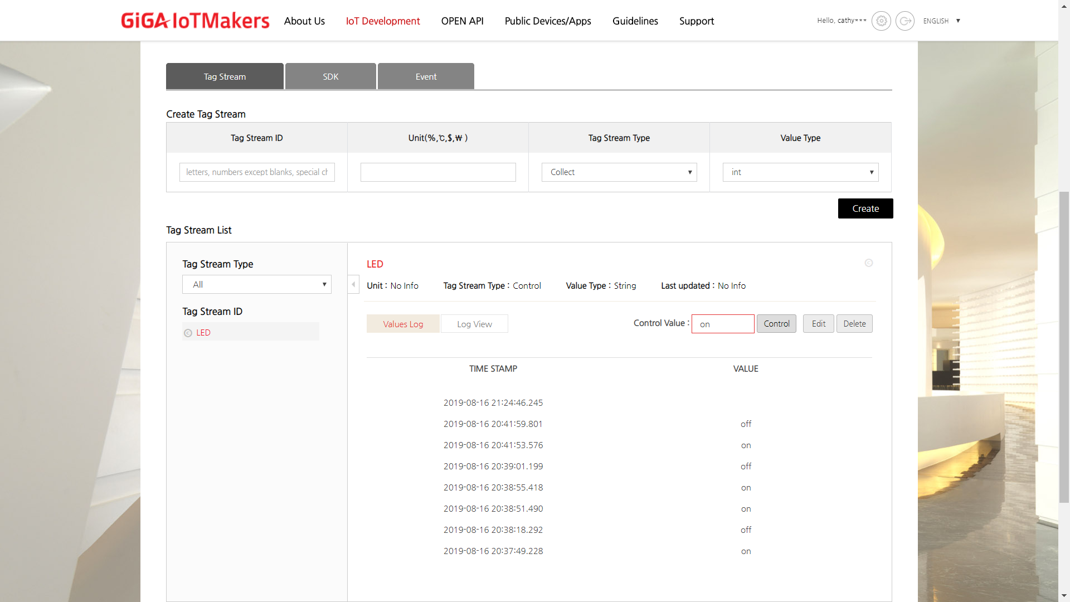

⑱ According to the control value transmission, LED on the target board is turned on/off and ‘**LED ON**’ or ‘**LED OFF**’ are output on the **serial monitor**.

